Linlithgow Community Development Trust - Executive Summary
We are a Community Development Trust established over 10 years ago (September 2015) and formed by residents to deliver change to benefit our community. Over 16000 people live in the Linlithgow ward, a mix of town, village and rural living with several pockets of deprivation. We enable the people who work, live and play in the Linlithgow ward to use local knowledge for community and global benefit. We work with residents of all ages and backgrounds, supporting seniors, families and young people, and have a no barriers approach so anyone can get involved. Our staff, trustees and volunteers are all local people focusing on projects prioritised by local people. Our vision is “Empowered, thriving communities where people work together to nurture innovation.” We focus within 3 priority areas:
- Environmental Initiatives - Encouraging waste reduction, resource reuse, and recycling within the community; promoting energy efficiency, encouraging sustainable transportation options and developing friendly green spaces.
- Improving Community Health and Wellbeing - Building connections, reducing social isolation, improving mental and physical health and well-being, increasing learning and skill-building
- Community Engagement -Empowering residents to develop innovative and sustainable solutions to create community benefit and capacity-building.
Annually we engage with over 5000 people through our environmental activities, improving health and wellbeing and improving our communities. We’ve already achieved some amazing results and built some wonderful projects with the support of dedicated staff and volunteers. We’ve been awarded the West Lothian Chamber of Commerce 2025 Environmental Champion of the Year Award. Our Linlith-Go-Solar project was nominated as 'Most Enterprising Community' in the National Loves Local Awards 2024. Our women’s hour cycling project was in contention for a National Inspiring Participation Award at the Scottish Cycling Awards 2025. Linlithgow was recently awarded the best place to live in Scotland for 2026 by The Sunday Times and stated that Linlithgow Community Development Trust was “the fuel in the engine of Linlithgow….a small but dedicated development trust.” And that we were “a considerable factor in deciding to award Linlithgow Scotland’s award”.

Our Strategic Priorities for the next 3 years are to:
- Grow our reuse and repair work. We want to engage more widely across our communities developing satellite venues which bring services to rural areas and for those where cost of living pressure is highest.
- Increase active and sustainable travel options for the community. We want to focus on understanding young people's views, ensuring their voices can be heard and their views used to influence future policy.
- Increase usage of our two main assets the West Lothian Cycle Circuit and our EH49 Hub venue. We want to engage with more groups whilst also increasing our social enterprise income potential. This will reduce reliance on grant funding in the long term and create a more sustainable funding stream to enable our Environmental work and support an increased number of people with their health and wellbeing.
- Create a coordinated structure of feedback and communication within our communities. We want their views and opinions to drive development and for local people become more confident and knowledgeable in engaging in community placemaking.

Our Work
The Needs We Are Addressing
Climate change is the defining issue of our lifetime, impacting on our way of life and the future of our planet. We have been in ‘a code red for humanity’ for all our existence (2015-2026), the warmest on record. The accelerating pace of climate change means many feel powerless, guilty and/or overwhelmed. These are appropriate responses to the real threat we face. This however leads to avoidance and detaching when there is always something happening in the world that pushes climate change down the agenda. Huge worldwide and day-to-day issues distract us from the urgency of the challenge and from thinking about what we can do about it in the here and now. But how we live and work locally can, and does, have an impact and that’s our aim to get people to work on it together. We advocate for and guide collective local thinking and action. We know that local engagement with a purpose helps individuals and groups, building community inclusion and supporting health and wellbeing. Our work is anchored in the 5 Ways to Wellbeing: Connecting, Being Active, Taking Notice, Learning and Giving. Building good relationships and connections with others, learning new skills and feeling more in control of life are all outcomes of our work.
Our Projects
- Our EH49 Hub community venue is secured on a maintenance lease from West Lothian Council, provides a base for our staff and key projects. In our venue we enable thousands of residents annually to connect and engage with others, share learning and skills and reduce social isolation. We host others to run group sessions as well as many of our own activities and events.
- We opened our 1km West Lothian Cycle Circuit track in May 2023. It gives people of all ages and abilities accessible opportunities to cycle, skate, wheel, walk and run for fun, health, sport and active travel. We increase cycling and wheeling inclusion and confidence by offering training and led rides. We provide dedicated group activities to support walking, cycling and wheeling. Including Women’s Hour, activities for children and young people (e.g at risk of exclusion from schools, experiencing poverty, care experienced). Our Cycle Kitchen repairs bikes and ensures safety. In 2025 we held our first successful Festival of Movement supported by around 20 partners.
- Our successful community solar project supported local sports clubs to reduce energy costs and build community surplus to invest back into the community to encourage most sustainable living.
- Share, Repair and Reuse Initiatives divert items from landfill and provide an alternative to buying new. Our thriving circular economy projects enable our communities to take action to combat climate anxiety.
- Tool library with 250 members and over 1000 tools loaned each year.
- Shed activity with 3 sessions a week supporting members at risk of isolation and mental health issues.
- A developing community repair service that has successfully repaired nearly 1000 items in its first year. Preventing them from entering landfill and supporting people on low income by reducing the cost of replacement (our service does not charge for labour, only parts.)
- Refab encourages upcycling and repair of textiles and teaching people skills to extend the life of clothing.
- Community Consultations (small and large) on local projects and on wider issues to ensure our services reflect public needs.
- Volunteering – all activities are open to volunteering for age 16+ with no upper age limit. We utilise the skills and experience of wonderful volunteers, and we couldn’t achieve what we do without them. They hold several key roles including Trustees, administration and project delivery roles (trainers and mentors). Our tool library, shed, recycling projects and West Lothian Cycle Circuit are great examples of projects which have grown and evolved due to volunteer involvement. We support those with mental health barriers, specific learning needs/additional support needs, LGBTQIA+ and those on low incomes to build confidence, have a sense of purpose and belonging. We have a strong online digital presence with two websites, a volunteering portal and 6 social media channels.

Our Impact
The development and construction of our £1.3m closed road cycle circuit West Lothian Cycle Circuit (WLCC) is run by our trust with a community led subcommittee. It supports community programmes and clubs as well as local events. Our first Festival of Movement ran in 2025 and engaged over 500 people. Our Active Travel School Hub ran a six week cycling programme with Linlithgow Academy to support pupils with additional support needs (ASN).
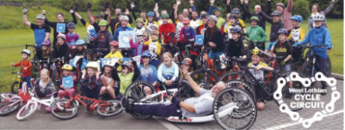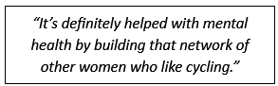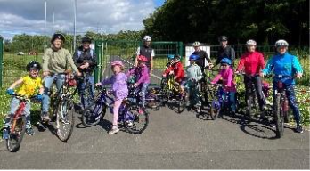
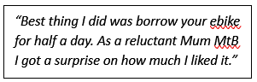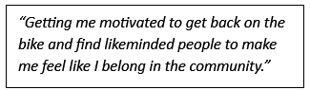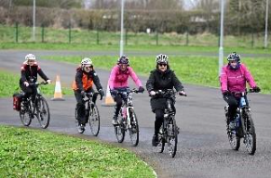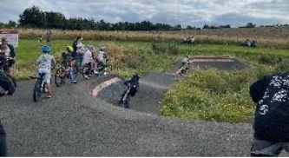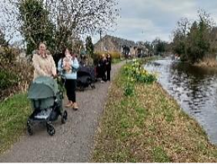
We improve the health and wellbeing of our community by providing opportunities for people of all ages (walking buses for schools to dementia walks in partnership with the local health centre). Our focus is not on sport for sport’s sake, but to encourage people to increase activity levels. We focus strongly on connecting people to their community and ensuring people do not feel isolated by supporting regular clubs and activities.
In our EH49 Hub we provide learning opportunities, enable skill-sharing and inspire creativity. We foster supportive environments to build camaraderie and create social networks for isolated individuals. This includes intergenerational exchange and providing purposeful activities, generating a sense of pride, achievement and fulfilment that their efforts contribute personally, locally and to the world.
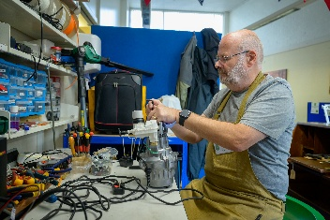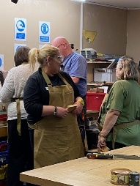
“It really gets you out of the house and learning how to fix stuff. Great for the environment and my mental health!"
"The encouragement from members of the group…..has been vital in motivating me and regaining my confidence”
“It does make you get out of the house, knowing there’s a specific time to meet and get back”
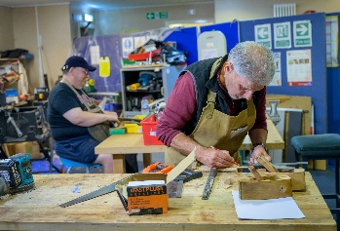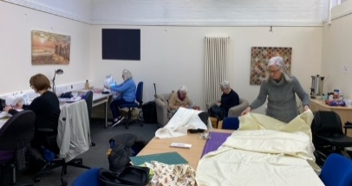
Our community bond project raised funds to install solar panels on 3 community buildings. This created around £6,000 per year surplus for community benefit. We have been able to pay all bond holder investment back 6 years earlier than initially planned. In total the project has generated savings of 66 tonnes of CO2 to date, enough to drive a car 13 times around the world. In 2024 we won the Edinburgh Remakery Award for the volume of tech devices recycled. These items have gone on to support projects for developing communities locally and abroad.

How do we measure success?
Of course, it is great to get local and national recognition for our work. However, we really measure our success by understanding our impact on individuals, on groups and on our world. In 2025 we reviewed and sharpened our strategy to really focus on what impact we want to make and what success looks like. This has been filtered down to an all staff work programme that highlights the project that they are working on, key milestones and how we will measure success. Unfortunately like a lot of smaller charities we haven’t had the capacity to shout about our impact as much as we would like. However, we are starting to gather positive stories and share these through our communication channels. This all helps us engage our community in understanding what more we can do to combat climate change, how they can get involved and the benefits for individuals.

We are focusing on improving monitoring and evaluation. Our data gathering so far has focused on number of attendees and on activities delivery (e.g number of items repaired, number of items diverted from landfill) with some qualitative case studies that highlight the true human, social and environmental impact. However, we want to start a pilot project using the social value engine tool. This will enable us to understand the wider impact of our projects. We are going to undertake a wide scale community conversation. This is a long-term commitment to creating a coordinated conversation which influences the future direction of the Linlithgow ward. Insight will be drawn from this on regular intervals through the year but is an open-ended piece of community engagement that will be part of our normal working practices and strategic priorities. We will gain views on current activities (our own and others), identify what gaps exist and what additional support people may need to embrace more environmentally sustainable habits.
Our Approach to Equity, Diversity and Inclusion
We support all members of our community and adopt a no barriers approach to getting involved. We learn from every interaction we have with participants and volunteers. We support volunteers and participants with lived experience and spend time to understand their perspectives. We focus on the support and adjustments they need rather than their barrier (e.g a health condition). We regularly ask about their needs as we know those needs change over time and adapt to meet these. We try to be realistic and transparent about what’s possible as a small organisation. We have safeguarding and equality policies underpinned by procedures developed to ensure that those involved are suitably trained and checked to work with vulnerable individuals.

By partnering with other organisations with considerable experience in supporting target groups, we benefit from their knowledge and use this to shape delivery that is user focused. (E.g Donaldsons school staff have strong knowledge and expertise in neurodivergence and support us in developing activities for people with intellectual disabilities). By approaching projects in this way, we build knowledge, confidence and reduce the barriers that prevent future engagement. We codesign projects with the specific communities we want to support. For example, we co-created a recent LGBTQIA+ and non-binary DIY session. This was based on how they wanted to experience the activity and resulted in a positive session. We then utilise any learning for future engagement. We work with No Limits', a West Lothian based multi-sports club who support around 50 children and young adults with disabilities (0-25 years). We support Cycling Without Age Scotland, who enhance and enrich lives by giving passengers access to the outdoors through trishaw rides ensuring access which is denied to so many simply because of age or limited mobility. The quality of our inclusion work was recognised at a national level with our women’s hour cycling project nominated for a National Inspiring Participation Award at the Scottish Cycling Awards 2025.
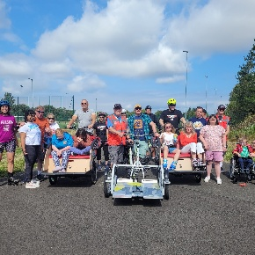
Our engagement with communities in Bridgend and Whitecross highlighted that transport poverty is a barrier to engagement. We worked with the local Bridgend food larder and Youth Space, a young people led organisation to consult with families on low income about cost-of-living challenges. This year we will provide repair cafes to repair essential household items, preventing them from having to buy new; our tool library to provide everyday tools preventing costly outlays as well as maintenance/storage and supporting energy efficiency and cost effective easy solutions to save money. This will support and empower local families in areas of high deprivation. Our aim is to develop volunteer led community steering group(s) with residents’ leadership.
Our Partnerships
We are well connected in the Linlithgow ward, across West Lothian and Scotland. Our staff, trustees and volunteers sit on various local boards, forums and meetings. We work closely with 50+ different groups and organisations including those that we partner with for delivery of activities or are regular users of our venues. We foster collaboration and partnerships with local organisations, businesses, community groups, and government entities to leverage collective expertise, resources, and efforts for greater impact that ensures community benefit. We actively work to bring people together to ensure we (and others) aren’t duplicating what’s already happening.
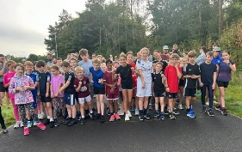
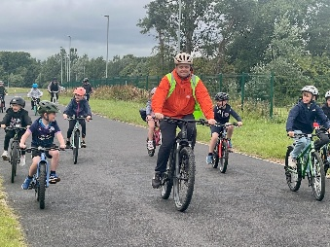
We work closely with Youth Space Linlithgow open to all young people aged 11-18 years old. We support them with programmes in Bridgend during term time and school holidays for disadvantaged young people. We partner with Linlithgow Athletics Association and with Park Run. We are starting projects with Donaldson’s Trust and their Learning Centre supporting neurodivergent children and young people to access volunteering opportunities. We partner with 1st Step who provide safe, supportive environments for people affected by addictions and poor mental health. We collaborate on our Cycle Kitchen venture providing DIY bike maintenance sessions. These are led by recovering addicts who have trained as mechanics and volunteers. We work with FEL Scotland (The Forth Valley and Loch Lomond and the Trossachs National Park Climate Action Hub) on our Active Travel schools Hub programme for all our primary and high schools. We partner with Edinburgh Remakery on developing ways to encourage the community to recycle their old technology. Over the past two years we have been recognised as being their most successful partner and are looking to expand the programme further.
We are working with Edinburgh University and are hosting a high-level student placement this year. They will undertake a qualitative piece of research. It will increase our insight into the factors that influence involvement in sustainable initiatives and circularity. The findings will influence our strategy and approach.
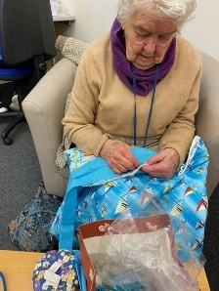
Case Studies
During her time attending the REFAB group, one of the participants suffered the bereavement of her adult son. The group dedicated their next session to making a ‘memory bear’ using some of his clothes and belongings. This provided the lady with comfort and support to work through her grief and pain, and she was extremely appreciative of this support from the group.
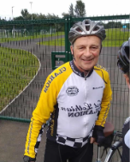
Our cycle circuit helped a local resident recover from brain surgery by providing a safe, traffic free environment for cycling and other sports. “I was a very keen club cyclist and runner for fifty years until brain surgery in 2021 significantly curtailed these activities for me. I was used to obtaining my fitness through outdoor activity such as running and cycling, this has been a big miss for me. I did manage to ride a two-wheel bike although mounting and dismounting was difficult. Practice was limited to car parks. I still do not have the confidence to go cycling on the open road and in this respect the Cycle Circuit has been of immense benefit to me as I build up my fitness, stamina, and confidence. After my ride on the circuit, we chain up our bikes and often spend nearly two hours in the café just chatting! The circuit has been a ‘life saver’ facility, maintaining my physical and mental well-being”

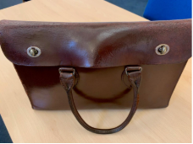
A customer brought in an old satchel to our repair shop that belonged to a relative that had sadly passed away. Repairing the item meant that not only the bag could be used again but also allowed them to share the story with our volunteers, keeping their relative’s memory alive. The emotion and joy that a simple repair gave meant so much.
We have a no barriers approach to volunteering and participation. This has been particularly helpful for many residents experiencing health issues, low confidence and social isolation. “in my struggle to recover from 7 months of Long Covid (and be well enough to return to my part time job) the support and encouragement from members of the Shed…..has been vital in motivating me and regaining my confidence” . West Lothian Council's Employability service asked us to support a man who had been out of work for a long period due to mental health challenges. They thought he would benefit from structured social activity around new people with the aim of increasing his confidence and improve his mental health. He came to 10 Shed sessions, supported by our lead volunteers to get involved in practical activities, build connections and his confidence.
A long-term volunteer with our Tool Library/ Repair Shop: “Volunteering at the Repair Shop has been a truly rewarding and eye-opening experience. The Repair Shop aims to tackle waste by fixing broken household items, fostering a sense of community, and encouraging sustainable living in the heart of Linlithgow. As a volunteer, I’ve gained new skills, met inspiring individuals, and contributed to a project that makes a tangible difference in people’s lives. My journey began when I signed up as a volunteer to the Tool Library, in itself an excellent vehicle to maximise resources, reduce waste, and in a cost-effective manner, ensure people have the correct equipment for their projects. As a founding volunteer in the Repair Shop, it’s been an exciting journey developing the processes, equipment and structure to safely carry out our repairs. Our aim is to promote environmental awareness by reducing landfill waste and encouraging a culture of reuse and repair. In addition, we generate funds that help support the Trusts running costs.

Each session at the Repair Shop is different, depending on what items are brought in by local residents. I’ve assisted with everything from mending pressure washers to small electronics. Collaboration is at the heart of the Repair Shop. We work together to diagnose faults, source spare parts, and explain the repair process to item owners. The atmosphere is friendly and inclusive, with plenty of opportunities to ask questions and share tips. I’ve particularly enjoyed the problem-solving aspect, each repair feels like its own little puzzle, and there’s immense satisfaction when an item is restored to working order. My experience volunteering with the Repair Shop within Linlithgow Development Trust has been incredibly positive. It’s an initiative that not only delivers tangible benefits but fosters an environment that delivers a true community spirit, wellbeing and sustainability. I am proud to be part of the Circular Economy”.

Projects arising from Community Needs: We received feedback from our community that they struggled to find places to recycle empty blister packs. Supported by our team, our volunteers established a drop off point at our EH49 Hub. We were able to recycle a total of 125,000 packs. In 2025 the partner we worked with changed their approach, so we had to suspend the service. We are about to relaunch it with a new partner for 2026.
Our People
Our Board of Trustees is comprised of eight people living and working locally. They have a range of backgrounds including HR, Facilities Management, Local Government, Funding and Charity Sector, Communications, Marketing and IT. Our Interim Chair. Tom Conn was a Valuation Surveyor and is now an Executive Councillor for Environment and Sustainability Our Treasurer, Brian Ashcroft is a retired Accountant. He worked in the food industry for 20 years and in retail before closing his career as a Finance Director. Fraser Falconer, now retired, was Head of the Children In Need in Scotland; Susan Smith is currently head of communications for one of Scotland’s largest charities; James Campbell is a senior IT Manager, Andrea Rossiter worked as a civil servant and has experience working on clean energy and climate change policy. Pamela Barnes is a Development Officer, Membership & Engagement Officer for Development Trusts Association Scotland. Pamela previously worked with us for a period of 6 years, prior to this she was Head of Research & Communications for Includem. She has now come full circle offering to volunteer her time on our Board.

Our Chief Executive is led by Lee Dolby our CEO. He has a background community development and health along with experience supporting sport and physical activity at local, regional and national level. He was the Deputy CEO of Lincolnshire Community and Voluntary Service. He managed an operational budget of circa £1m running a large NHS Social Prescribing contract. He was responsible for data and insight management and communication and marketing. In previous roles he led on countywide Youth Games, volunteer and coaching awards/conferences through to more national projects including overseeing the preparation and competition of the GB team to the 2013 Deaflympics in Sofia. He was also an advisor to the London Organising Committee of the 2012 Olympic Games (LOCOG) on Disability and inclusive practice.
Our Aspirations
We want to:
- Ensure that our communication and engagement is getting to the heart of what the community really want and need. We can then flex our strategy and delivery to ensure that we are truly community led, reacting to needs as they evolve and change. This includes co design of services especially with people with lived experience and knowledge about what really matters to them.
- Raise aspiration and nurture ideas and support people to enact meaningful change and impact. By working with those with passion we hope to create interventions that inspire lasting change and improvement in people's lives, led by the community for the community.
- Increase the number and range of communities that we support to create greater reach and benefit and ensure that no communities are left behind.
- Continue to build productive partnerships with other organisations and align resources to create greater impact, stretching what is probable to really reach for what is possible.
- Embrace the benefits that technology can bring to the organisation and use this to create easier ways for people and staff to engage.
- Improve how we articulate the change that we achieve, how we share more widely the story of the people and places we work with and the impact we are having.
- Continue to develop the organisation to be effective and well run to allow maximum resources to be targeted at the community and reduce our time spend dealing with inefficient systems

Income Plan
We do not receive any contract income for delivery of our services. We have confirmed funding from the Communities Mental Health & Wellbeing Fund and the Volunteer Support Fund, DTAS Strengthening Communities Programme, Hugh Fraser Foundation and the Souter Charitable Trust We have also just been awarded capital funding from Cycling UK Access Fund for a Bothy at our West Lothian Cycle Circuit. In recognition of the quality of our work, we have been awarded a further year's funding by SESTran to continue our active travel work. We have been awarded match funding by the Big Give for a fourth campaign year in a row. We have an annual rolling programme of applying to Scottish and UK wide Trusts and Foundations and have applications pending with several smaller Trusts (£1-5K).

We also generate income from our West Lothian Cycle Circuit, our Tool Library and Repair Shop (which helps sustains these projects), and our community solar project. We want to increase this social enterprise income model. Over time with funding support, we would transition into having a bricks and mortar repair shop instead of pop-up events. Funding we have recently secured from the Strengthening Communities Programme will provide a new full time business growth manager to help drive this aspiration forward.

We do raise funds locally especially where there are match opportunities (e.g the Big Give Fund) – we have run a campaign annually for the last 4 years asking our local community to support our environmental efforts. We also get support from Local Rotary organisations. We utilise networks to ask local businesses for corporate sponsorship especially of events at our West Lothian Cycle Circuit. This year our shed project was the benefactor of the towns annual Christmas tree festival. This provided funds for vital upgrades to machines and training for volunteers.

